CODING ASSESMENT – PYTHON

[Jobaoushadancse2021@jerusalemengg.ac.in](mailto:Jobaoushadancse2021@jerusalemengg.ac.in)

Job Aoushadan N – 29.07.2025

1. Data Cleaning

Importing pandas and using,

df.info(),

df.describe(),

df.head()

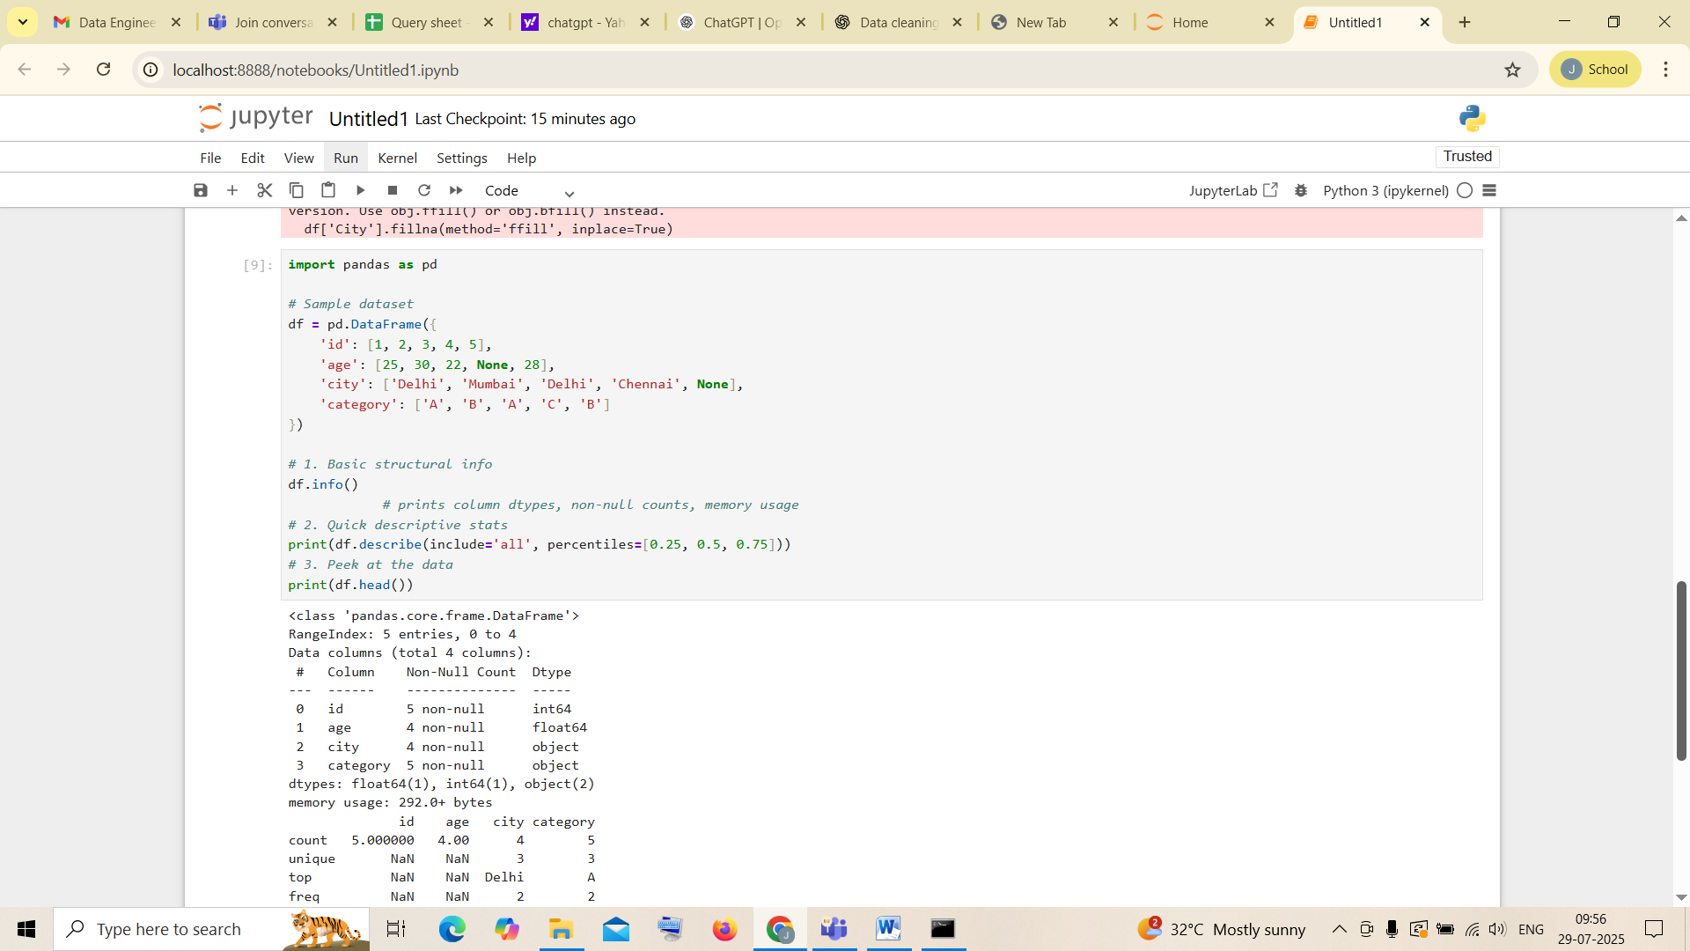

2. Pandas Joins:

Creating another dataframe to join

Inner Join

Left Join

Right Join are performed in the screenshot below

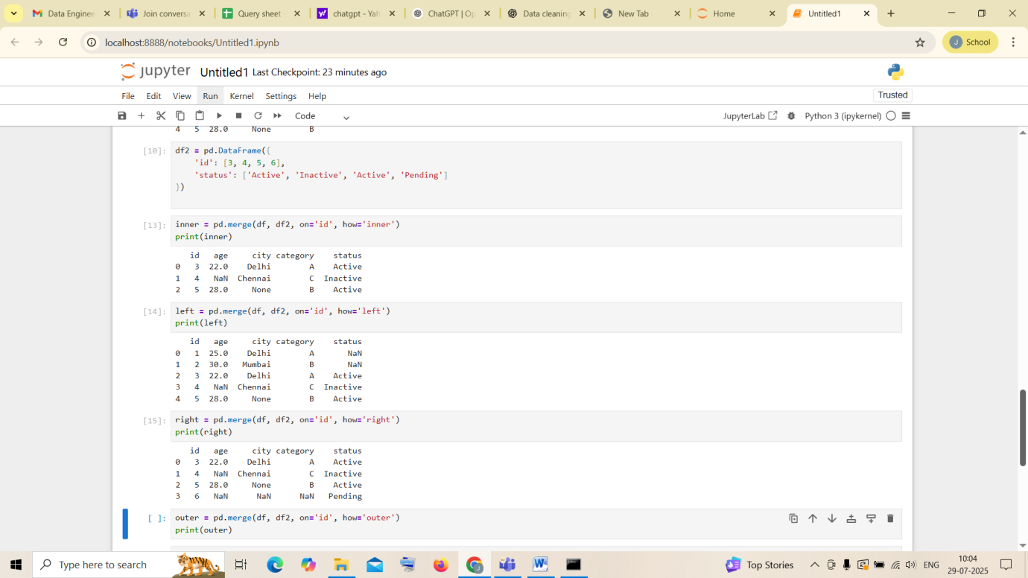

Outer Join

Cross Join are performed below

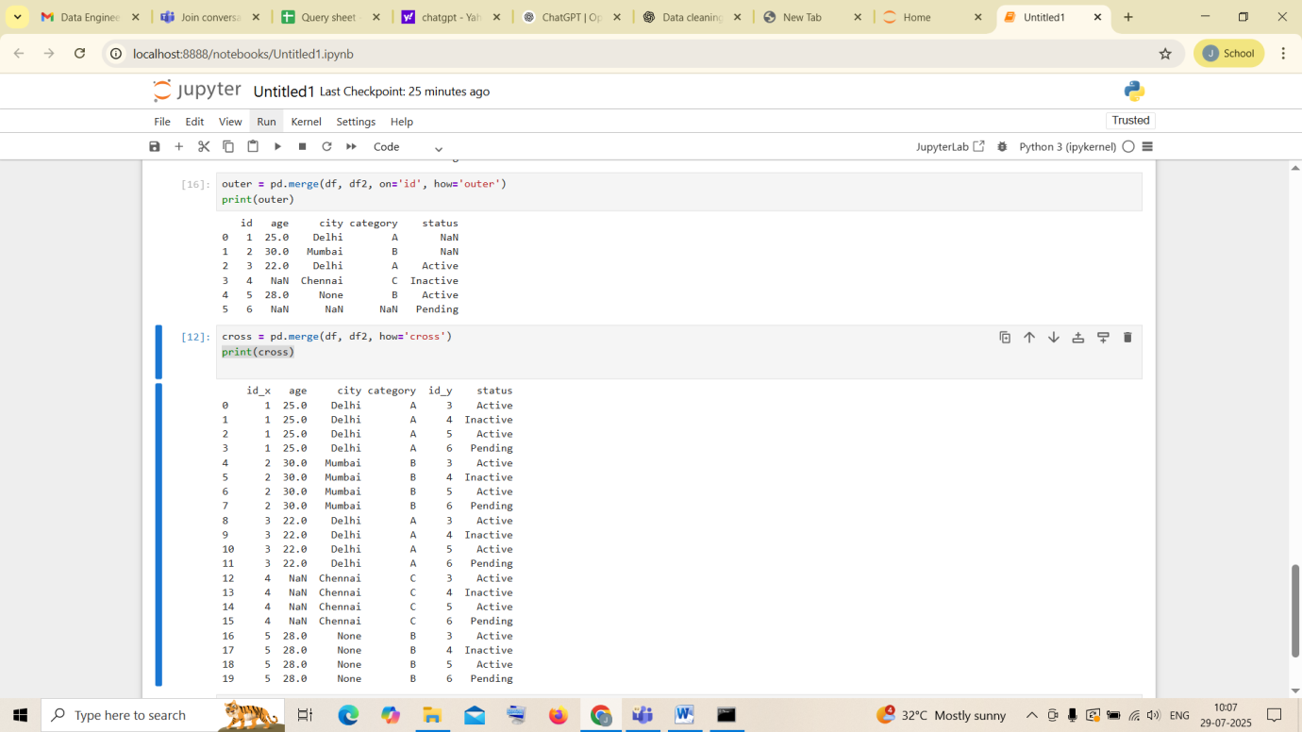

Code:

import pandas as pd

# Sample dataset

df = pd.DataFrame({

'id': [1, 2, 3, 4, 5],

'age': [25, 30, 22, None, 28],

'city': ['Delhi', 'Mumbai', 'Delhi', 'Chennai', None],

'category': ['A', 'B', 'A', 'C', 'B']

})

# 1. Basic structural info

df.info()

# 2. Quick descriptive stats

print(df.describe(include='all', percentiles=[0.25, 0.5, 0.75]))

# 3. Peek at the data

print(df.head())

df2 = pd.DataFrame({

'id': [3, 4, 5, 6],

'status': ['Active', 'Inactive', 'Active', 'Pending']

})

inner = pd.merge(df, df2, on='id', how='inner')

print(inner)

left = pd.merge(df, df2, on='id', how='left')

print(left)

right = pd.merge(df, df2, on='id', how='right')

print(right)

outer = pd.merge(df, df2, on='id', how='outer')

print(outer)

cross = pd.merge(df, df2, how='cross')

print(cross)